**Experiment No:** 13

**Experiment Name:** Introduction to PHP and installation of XAMPP server.

**Theory:**PHP is a general-purpose scripting language geared towards web development. It was created by Danish-Canadian programmer Rasmus Lerdorf in 1993 and released in 1995. The PHP reference implementation is now produced by the PHP Group. PHP was originally an abbreviation of Personal Home Page, but it now stands for the recursive initialism PHP: Hypertext Preprocessor. PHP is a widely

used, open-source scripting language for the backend. PHP files have the extension ".php".

**Web Server:** A web server is a program that processes the network requests of the users and serves them with files that create web pages. This exchange takes place using the Hypertext Transfer Protocol (HTTP). XAMPP is a free and open-source cross-platform web server solution stack package developed by Apache Friends, consisting mainly of the Apache HTTP Server, MariaDB database, and interpreters for

scripts written in the PHP and Perl programming languages and it is easy to use.

**Installation of XAMPP:**

Step 1: Download XAMPP software from https://www.apachefriends.org/download.html

Step 2: Double-click on the downloaded .exe file then a pop-up will come up.

Step 3: Keep Clicking on the next button according to instructions.

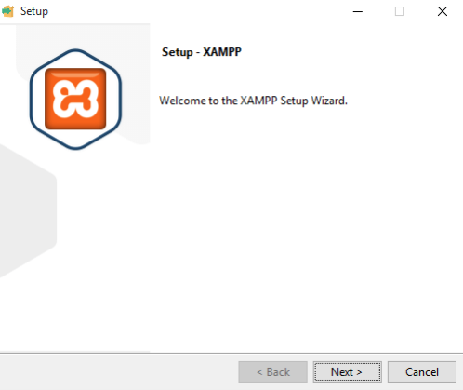 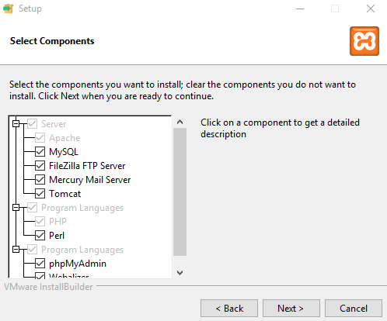

**Figure: Installation process of XAMPP server**

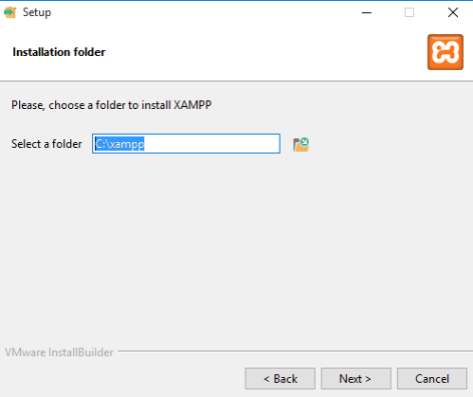 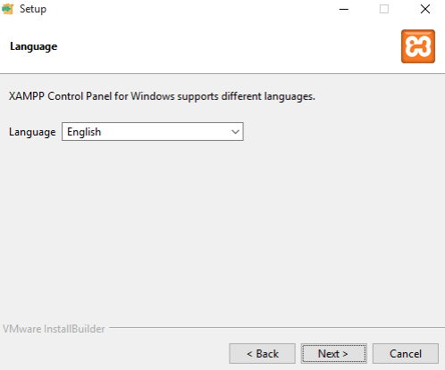

**Figure: Installation process of XAMPP server**

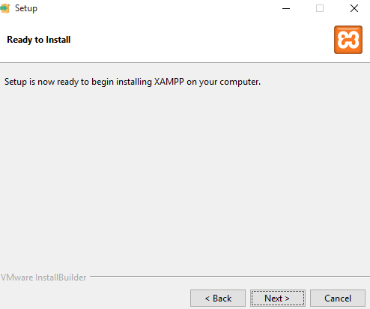 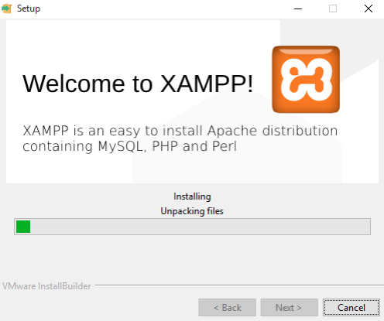

**Figure: Installation process of XAMPP server**

** After installation open the XAMPP Software and start the Apache

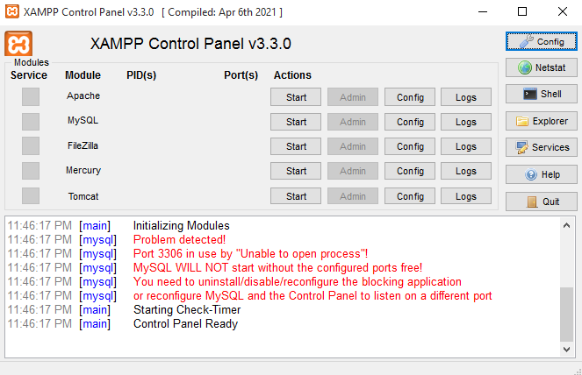 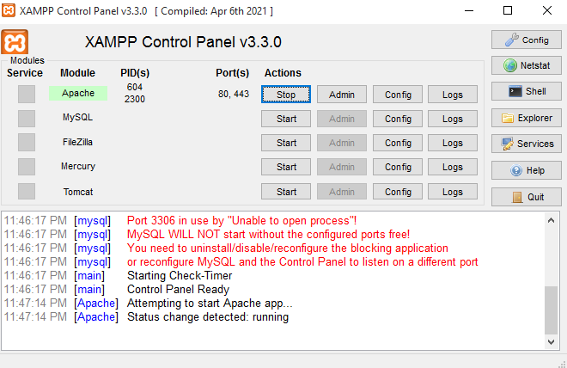

**Figure: XAMPP control panel**

When the XAMPP server successfully starts to run, the XAMPP Apache will be highlighted.Then go to browser and write down in the URL box: http://localhost and the following interface will be presented :

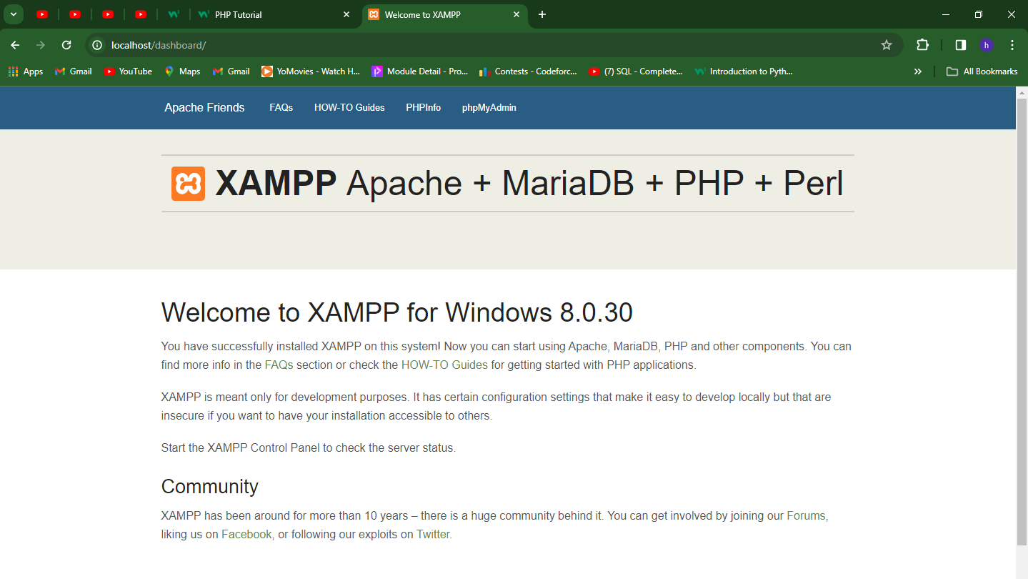

**Figure: Dashboard - XAMPP server**

**Lab Task-1:** Create a PHP script that:

● Defines two variables: one for your name (a string) and one for your age (a number).

● Concatenate these two variables in a sentence like: "My name is ABC and I am 25

years old."

● Create an array with three of your favorite colors and print each color on a new line.

**Source Code:**

**<?php**

**$name = "ABC";**

**$age = 25;**

**$sentence = "My name is " . $name . " and I am " . $age . " years old.";**

**echo $sentence . "\n";**

**$favorite_colors = array("Black", "White", "Blue");**

**foreach ($favorite_colors as $color) {**

**echo $color . "\n";**

**}**

**?>**

**Output:**

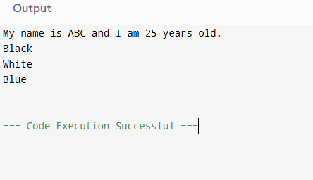

**Lab Task-2:** Write a program in PHP that checks if a given number is even or odd, and outputs "Even" if the number is divisible by 2, or "Odd" otherwise.

**Source Code:**

**<?php**

**$number = 39;**

**if ($number % 2 == 0) {**

**echo $number . " is Even";**

**} else {**

**echo $number . " is Odd";**

**}**

**?>**

**Output:**

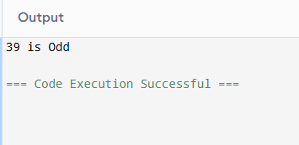

**Lab Task-3:** Write a function in PHP called *‘addNumbers’* that takes two numbers as arguments, adds them together, and returns the sum.

**Source Code:**

**<?php**

**function addNumbers($num1, $num2) {**

**$sum = $num1 + $num2;**

**return $sum;**

**}**

**$num1 = 12;**

**$num2 = 21;**

**$result = addNumbers($num1, $num2);**

**echo "The sum of " . $num1 . " and " . $num2 . " is " . $result;**

**?>**

**Output:**

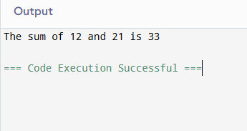

**Lab Task-4:** Create a program in PHP that can write the numbers 1 to 10 into a file named *‘numbers.txt’* using a *for loop*. After writing, read the file and check each number. If the number is even, print "X is even", otherwise print "X is odd".

**Source Code:**

**<?php**

**$filename = 'numbers.txt';**

**$file = fopen($filename, 'w');**

**for ($i = 1; $i <= 10; $i++) {**

**fwrite($file, $i . "\n");**

**}**

**fclose($file);**

**$file = fopen($filename, 'r');**

**while (!feof($file)) {**

**$number = fgets($file);**

**if (trim($number) != '') {**

**if ($number % 2 == 0) {**

**echo $number . " is even\n";**

**} else**

**{**

**echo $number . " is odd\n";**

**}**

**}**

**}**

**fclose($file);**

**?>**

**Output:**

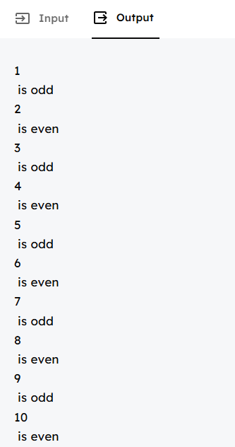

**Discussion:** In today’s lab report we got introduced about PHP and installation process of XAMPP server.PHP is a general-purpose scripting language geared towards web development. It was created by Danish-Canadian programmer Rasmus Lerdorf in 1993 and released in 1995. The PHP reference implementation is now produced by the PHP Group. PHP was originally an abbreviation of Personal Home Page, but it now stands for the recursive initialism PHP: Hypertext Preprocessor. PHP is a widely used, open-source scripting language for the backend.